PROJECT NAME

Cosmetics Store Management

# BY

Mupparthi Sahithi

21kd1a0265@lendi.org

## Abstract

This project focuses on the creation of a Cosmetics Store Management system utilizing Salesforce to enhance operational efficiency and customer engagement. The proposed solution integrates essential functionalities such as sales management, inventory tracking, customer relationship management (CRM), and marketing automation. By harnessing Salesforce’s capabilities, the project aims to streamline the sales process, optimize inventory levels, and personalize customer interactions based on purchasing behaviors and preferences. Additionally, robust reporting and analytics tools will be implemented to provide insights into sales performance and market trends, facilitating informed decision-making. The project includes a structured implementation plan involving requirements gathering, system configuration, data migration, and comprehensive user training to ensure effective adoption. Ultimately, this initiative aspires to improve operational workflows, boost sales, and elevate customer satisfaction in the cosmetics retail environment.

## Cosmetics Store Management

**Description :**

Cosmetics Store Management in Salesforce is a solution that helps cosmetics stores manage their operations efficiently and effectively. The solution is built on the Salesforce platform, which provides a powerful and scalable platform for managing customer relationships,sales, and inventory.cosmetics stores improve their operational efficiency, enhance customer engagement, and drive growth.

**Summary :**

1. **Key Features:Customer Management:**

■ **Contacts & Accounts:** Efficiently manage customer details, including contact information, purchase history, and preferences.

■ **Customer Segmentation:** Segment customers based on various criteria such as purchase frequency, product preference, and location for targeted marketing.

1. **Product Management:**

■ **Product Catalog:** Maintain an up-to-date catalog of cosmetic products with detailed descriptions, pricing, and availability.

■ **Inventory Tracking:** Monitor stock levels, set reorder points, and track inventory turnover to ensure optimal stock levels.

1. **Sales Management:**

■ **Order Processing:** Automate the order management process, including order creation, status tracking, and invoicing.

■ **Sales Analytics:** Generate reports and dashboards to analyze sales trends, identify top-selling products, and forecast future sales.

1. **Marketing & Promotions:**

■ **Campaign Management:** Create and manage marketing campaigns, including email promotions, discounts, and special offers.

■ **Customer Engagement:** Use Salesforce tools to engage with customers through personalized offers and targeted marketing.

1. **Customer Service:**

■ **Case Management:** Track and resolve customer service issues and complaints efficiently.

■ **Knowledge Base:** Provide customers with access to a self-service portal for FAQs, product information, and troubleshooting.

1. **Integration & Automation:**

■ **Salesforce Integration:** Integrate with other systems such as ERP or e-commerce platforms to ensure seamless data flow.

■ **Workflow Automation:** Automate repetitive tasks and processes to increase operational efficiency and reduce manual errors

**TASKS :**

1.Creating the Objects :

To Create an object:

Creation of Objects for Urban Color, For this Urban Color we need to create 3 objects i.e .,Our Customers,Consultants,Retailers,others.

The below steps will assist you in creating those objects.

* Click on the gear icon and then select Setup.
* Click on the object manager tab just beside the home tab.
* After the above steps, have a look on the extreme right you will find a Create

Dropdown click on that and select Custom Object.

* Creation of Our Customer Object

On the Custom Object Definition page, create the object as follows:

* Label: Our Customer
* Plural Label: Our Customers
* Record Name: Our Customer
* Check the Allow Reports checkbox
* Check the Allow Search checkbox
* Click Save.
* Now create a custom tab. Click the Home tab, enter Tabs in Quick Find and select Tabs.
* Under Custom Object Tabs, click New.
* For Object, select Our Customer.
* For Tab Style, select any icon.
* Leave all defaults as is. Click Next, Next, and Save.

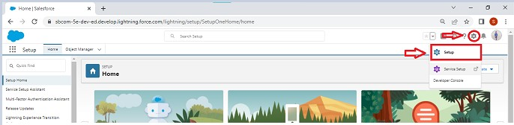

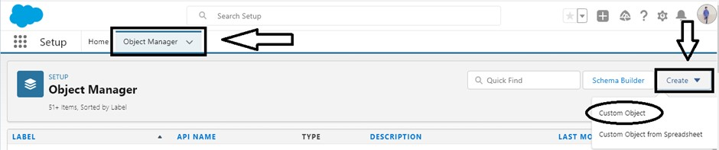

We need to create 4 objects named Our customer,Consultant,Retailer,Others.

For creating the another 3 objects,we need t follow the same procedure as mentioned above.

After the completion of object creation task,We'll move on to further steps.

**Task2 : Creating Fields and Relationship**  **:**

* An object relationship in Salesforce is a two-way association between two objects. Relationships are created by creating custom relationship fields on an object. This is done so that when users view records, they can also see and **access related data.**

**Fields in Our Customers objects** **:**

Fields in Our Customers objects follow below data types:

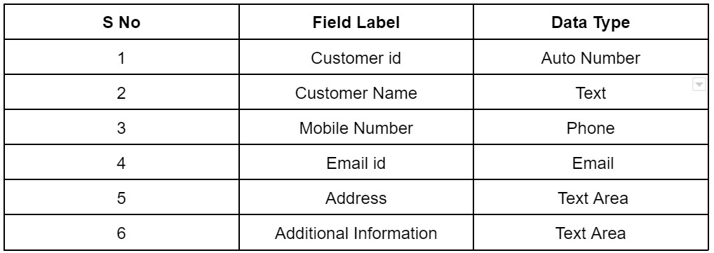

### Fields in Consultants objects

Fields in Consultants objects follow below data types:

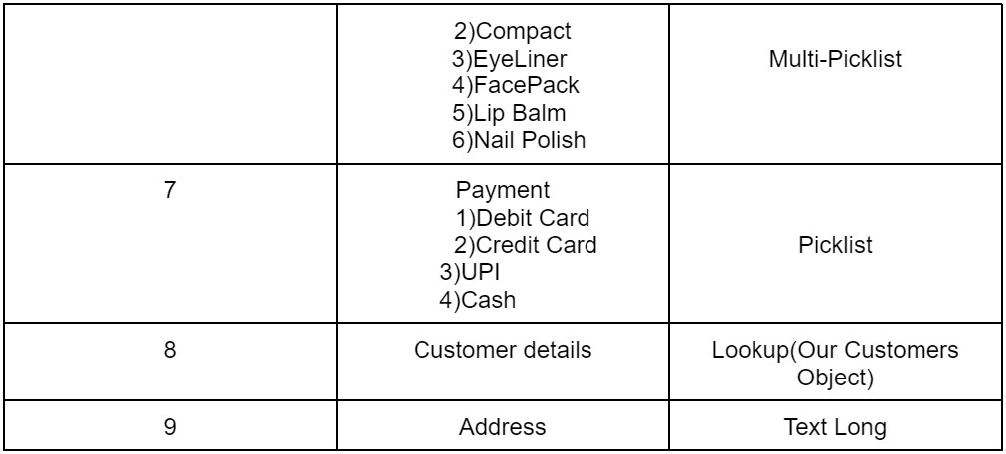

Fields in Retailers objects

Fields in Retailers objects follow below data types:

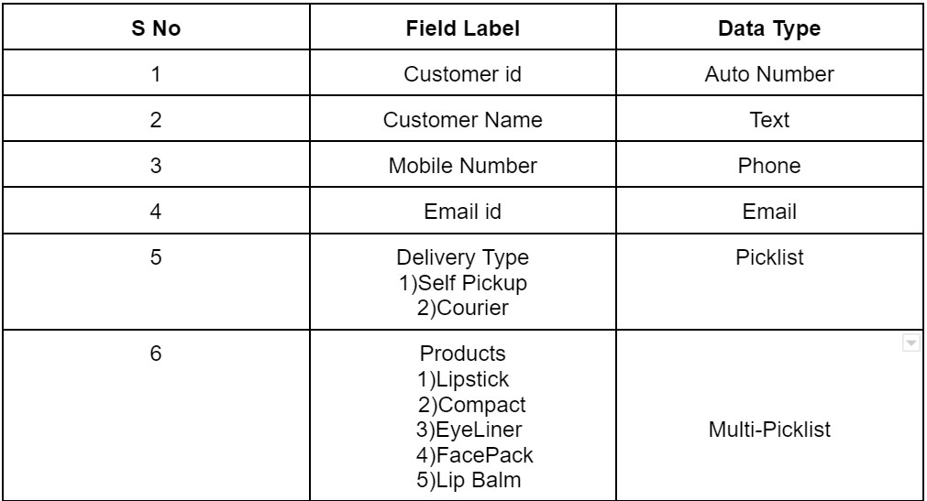

Fields in Others objects

Fields in Others objects follow below data types:

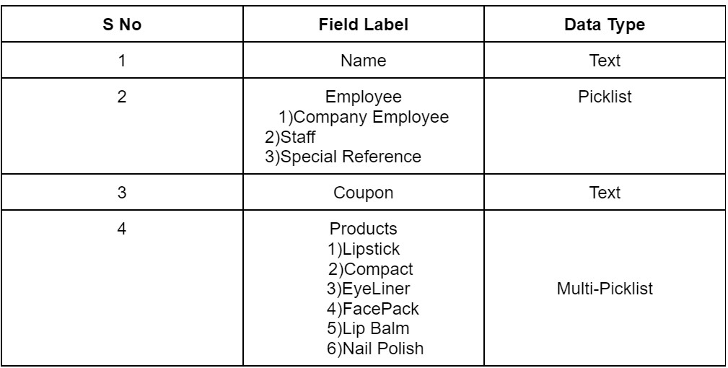

● In the Cosmetic Store Management System built on Salesforce, fields and relationships are designed to streamline operations and enhance data management. Key fields include customer details (e.g., contact information and purchase history), product specifics (e.g., SKU, price, and inventory levels), order details (e.g., order status and shipping info), marketing campaign attributes, and case management elements. Relationships are structured to connect these fields efficiently: customers can have multiple orders and cases, each order can include multiple products, and products are linked to inventory and suppliers.

1. **Task 3: Page Layout creation :**

From the Salesforce setup menu, go to "Object Manager" and select the Consultants object.

1. Click on "Page Layouts" in the left sidebar. This will display a list of available page layouts for the selected object.

3.Select the Consultant Layout page layout.

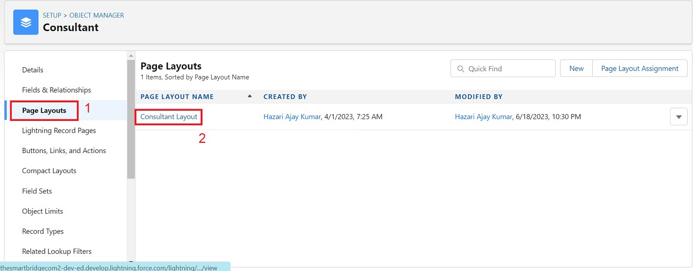

4.Click And Drag Delivery type and Address Fields Below Phone field.

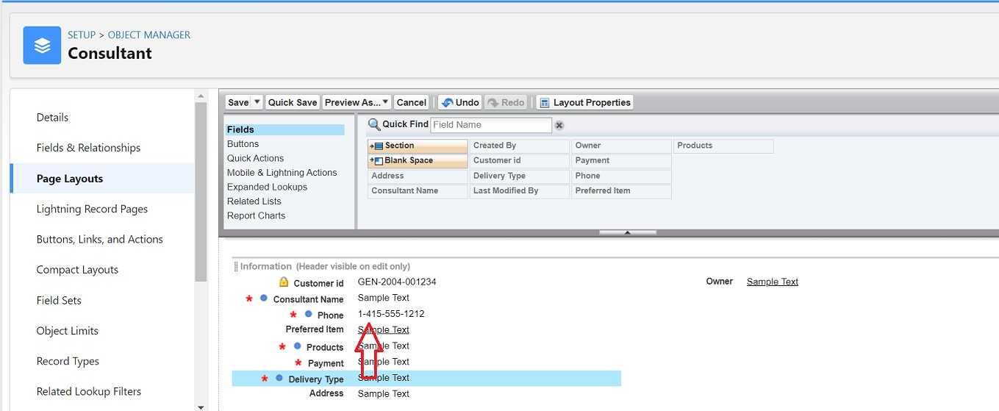

5.Click on Save

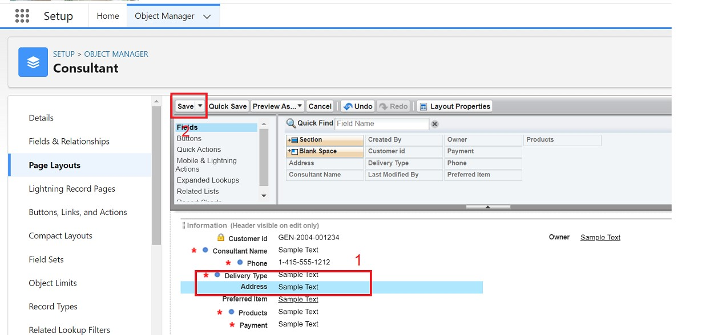

* Creating a page layout in Salesforce involves navigating to the object manager, selecting the relevant object, and either creating a new layout or editing an existing one. You can design the layout by dragging and dropping fields, adding sections and related lists, and including buttons or links as needed. Customize field properties and section settings to suit user needs, then save and assign the layout to specific profiles or record types. Finally, preview and test the layout to ensure it is functional and meets user requirements.

➤ **Task 4 : Creation of a Lightning App :**

* An app is a collection of items that work together to serve a particular function. In Lightning Experience, Lightning apps give your users access to sets of objects, tabs, and other items all in one convenient bundle in the navigation ba**r**
* To create a lightning app page:

1.Go to setup page --> search “app manager” in quick find --> select “app manager” --> click on New lightning App.

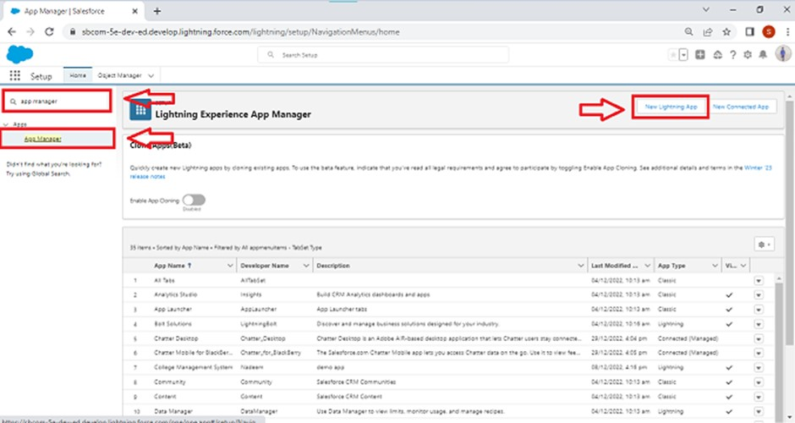

2.Fill the app name as Urban Color in app details and branding --> Next --> (App option page) keep it as default --> Next --> (Utility Items) keep it as default --> Next.

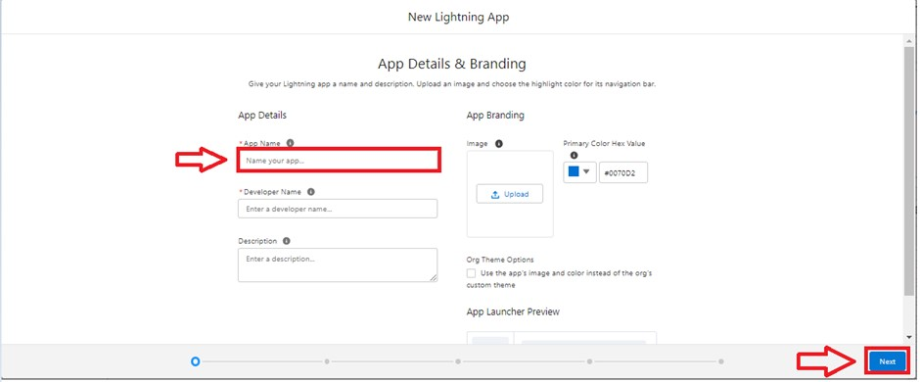

3.To Add Navigation Items

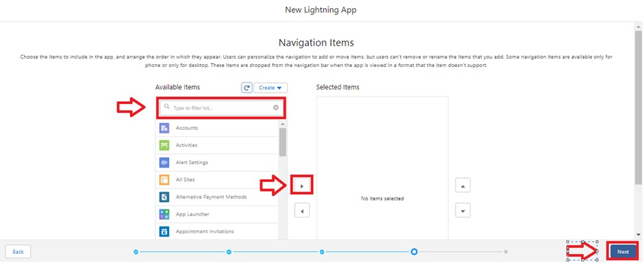

4.Select the items (Our Customers,Consultants,Retailers,Others,Reports,Dashboards ) from the search bar and move it using the arrow button --> Next.

5.To Add User Profiles:

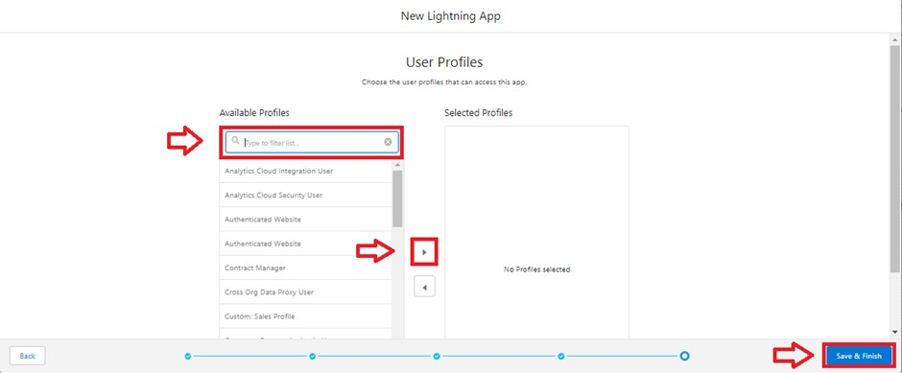

6 .Search profiles (System administrator) in the search bar --> click on the arrow button -> save & finish.

➤ **Task 5: Creating Profiles :**

* + A profile is a group/collection of settings and permissions that define what a user can do in salesforce. A profile controls “Object permissions, Field permissions, User permissions, Tab settings, App settings, Apex class access, Visualforce page access,

Page layouts, Record Types, Login hours & Login IP ranges.

Creating a Profiles: Now create a Store Supervisor profile and set its object permissions. Creating a Profiles:

Now create a Store Supervisor profile and set its object permissions.

* + From Setup enter Profiles in the Quick Find box, and select Profiles.
  + From the list of profiles, find Standard User.
  + Click Clone.
  + For Profile Name, enter Store Supervisor.
  + Click Save.
  + While still on the Store Supervisor profile page, then click Edit.
  + Scroll down to Custom Object Permissions and give access for

Create,Read,Edit,Delete,View all and modify all for Our

Customers,Consultants,Retailers,Others.

* + Scroll down to Custom App Settings and give access for Urban Color.

To create a new profile:

1. Go to setup --> type profiles in quick find box --> click on profiles --> clone the desired profile (standard user is preferable) --> enter profile name --> save.
2. While still on the profile page, then click Edit

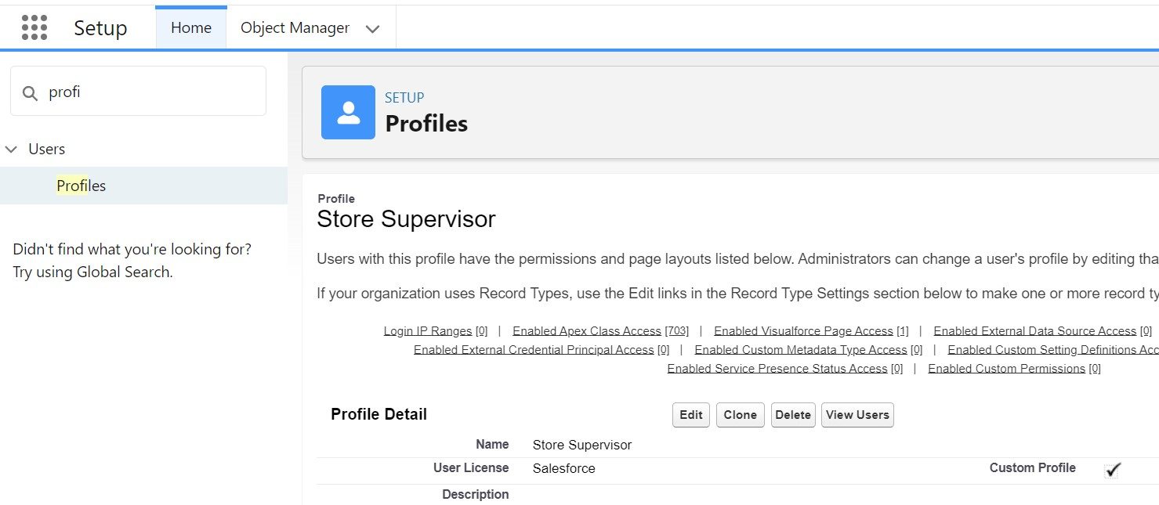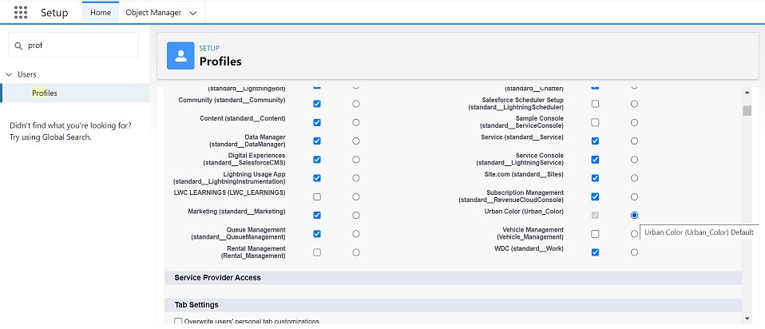

1. Click on Save.
2. Similarly Create operator profile ,Clone Salesforce Platform user and give access only for

Billing Operator.

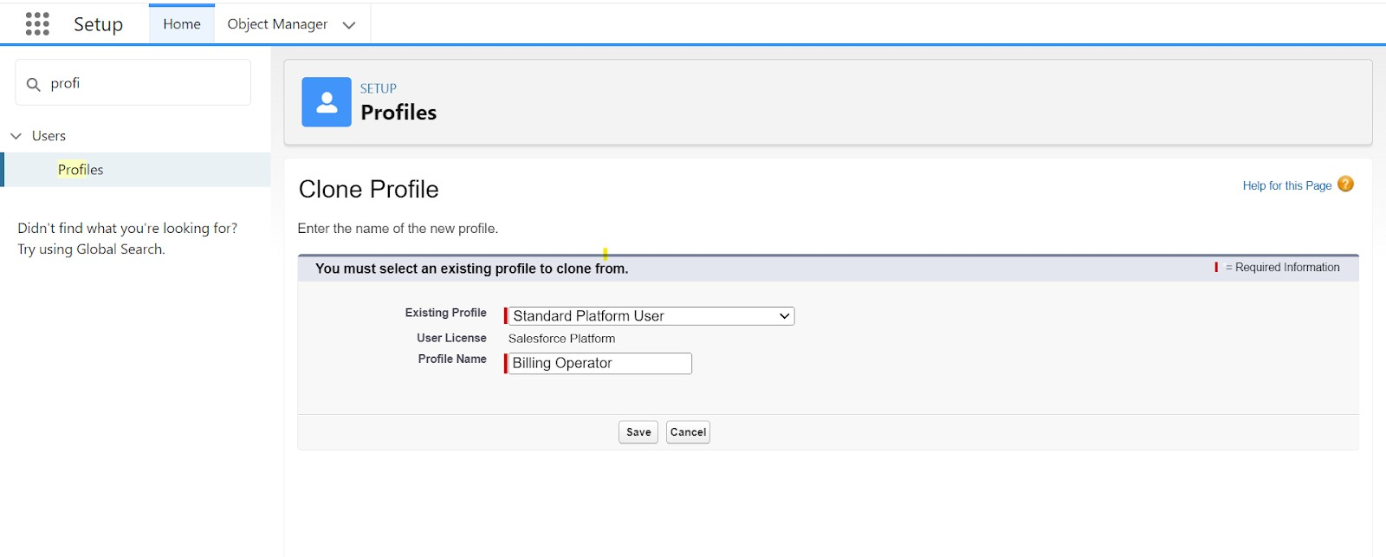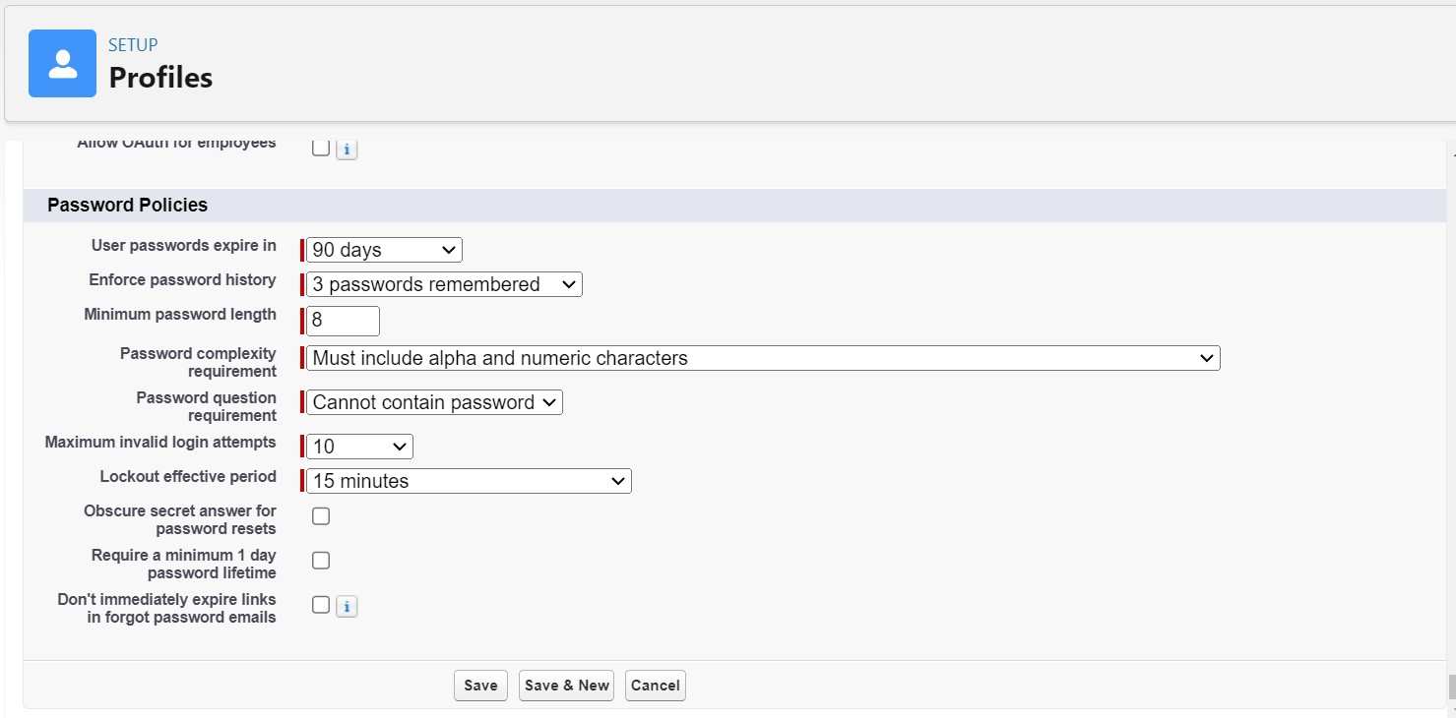

5.Click On Save

**Task 6: Setting up Roles :**

● Roles are record-level access controls that define what data a user can see in Salesforce.

1. Click on the Gear Icon
2. Click "Setup"
3. In the Quick Find box, enter "Roles"
4. Click "Roles"
5. Click on "Set Up Roles"
6. Click "Expand All"
7. Under the CEO, click on "Add Role"
8. Fill up the Label as Store Head, Role Name Store_Head.
9. Enter a Role name that will be displayed on Reports
10. Click on Save .

Similarly create One Roles under Store Head as Billing Operator.

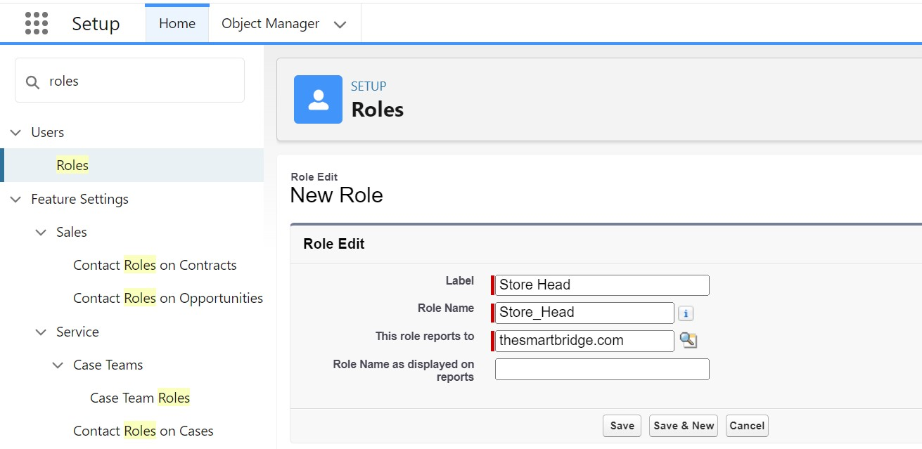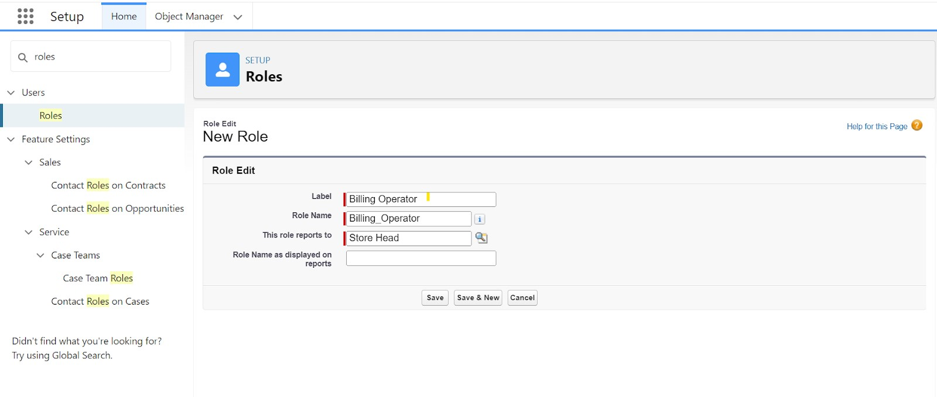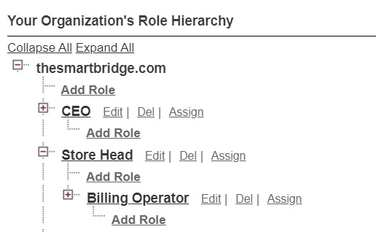

* + - In Salesforce, roles define the hierarchy and access levels for users within an organization. Roles determine the visibility of records and data sharing based on an employee's position and responsibilities. By establishing a role hierarchy, Salesforce allows users to access and manage records owned by users in roles below them in the hierarchy. This ensures that managers can oversee the work of their subordinates while maintaining data security and privacy. Roles are crucial for configuring access controls, enabling effective data sharing, and facilitating proper reporting within Salesforce. ➤ **Task 7 : Creation of an User :**
    - In Salesforce, a user represents an individual who has access to the Salesforce platform and its functionalities. Each user is assigned a unique username, and their access level and permissions are defined by their profile and role within the organization. Users can perform tasks such as managing records, running reports, and collaborating with team members based on their assigned permissions. Salesforce administrators configure user settings, including login credentials, security settings, and access to various features and data, ensuring that users can efficiently and securely perform their job functions.
    1. From Setup, in the Quick Find box, enter Users, and then select Users.
    2. Click New User.
    3. Enter the user’s name Amar K and (Your) email address and a unique username in the form of an email address. By default, the username is the same as the email address.
    4. Select a Role(Store Head)
    5. Select a User Licence As Salesforce.
    6. Select a profile as Store Supervisor.
    7. Check Generate new password and notify the user immediately to have the user’s login name and a temporary password emailed to your email.

Fill in the fields (first name, last name, alias, email id, username, nick name, role, user licence, profiles) --> save.

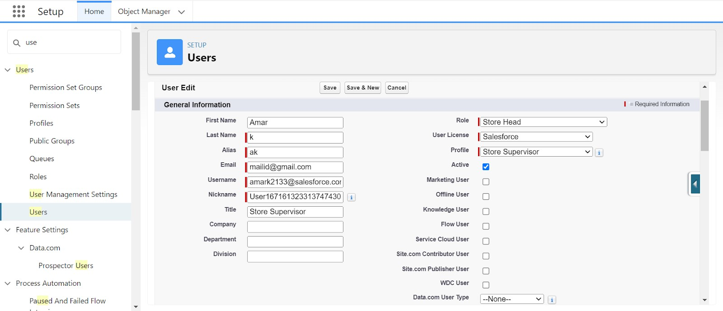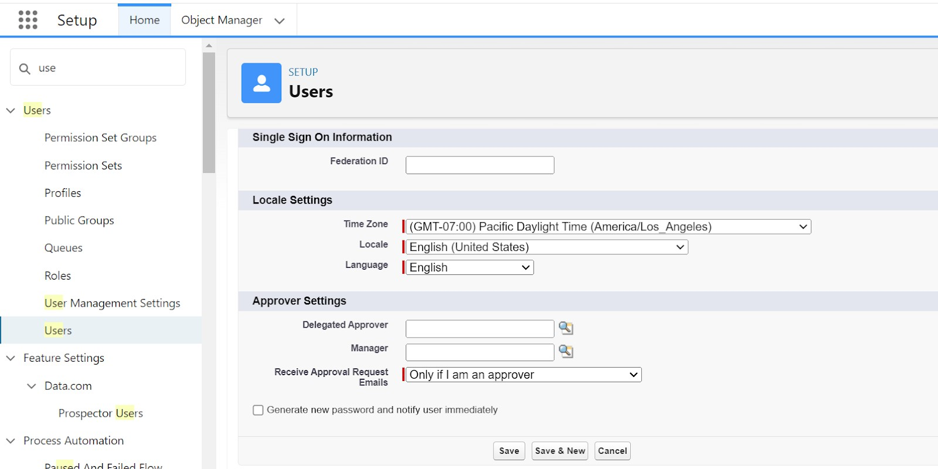

**Task 8 : Creating/Modifying Records :**

● Creating or modifying records in Salesforce involves navigating to the relevant object tab, clicking “New” to create a record or “Edit” to update an existing one. For creating records, users fill out the necessary fields and click “Save” to store the new data. For modifications, users locate the record, make the desired changes in the editable fields, and then click “Save” to apply the updates. This process ensures accurate and up-to-date information within the Salesforce system.

**Steps to Create a Record:**

* + 1. **Navigate to the Object Tab:**

■ Log in to Salesforce and go to the relevant object tab (e.g., Accounts, Contacts,

Opportunities).

* + 1. **Click “New”:**

■ On the object’s home page or list view, click the “New” button to initiate the creation of a new record.

* + 1. **Enter Record Information:**

■ Complete the fields in the record form with the required and optional data. This may include details like names, addresses, dates, and other relevant information.

* + 1. **Save the Record:**

■ Once all necessary information is entered, click “Save” to create and store the new record in Salesforce.

**Steps to Modify a Record:**

* + 1. **Find the Record:**

■ Locate the record you want to modify by using the object’s list view, search function, or related lists.

* + 1. **Open the Record:**

■ Click on the record’s name to open it and view its details.

* + 1. **Click “Edit”:**

■ In the record’s detail view, click the “Edit” button to enable editing mode.

* + 1. **Update Record Information:**

■ Make the necessary changes to the fields as required. Ensure all required fields are correctly filled out.

* + 1. **Save the Changes:**

■ After making the updates, click “Save” to apply and store the modifications.

These steps ensure that records are properly created and updated, maintaining accurate and current data in Salesforce.

➤ **Task 9: Importing Data :**

Data Import Wizard—this tool, accessible through the Setup menu, lets you import data in common standard objects, such as contacts, leads, accounts, as well as data in custom objects.

* 1. From Setup, click the Home tab.
  2. In the Quick Find box, enter Data Import and select Data Import Wizard

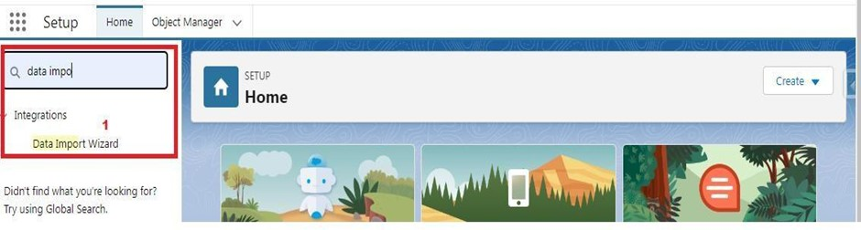

* 1. Click Launch Wizard!

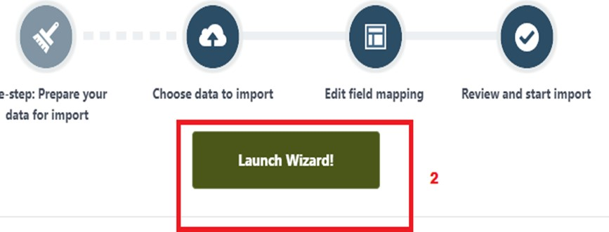

* 1. Click the Custom Objects tab and select the Consultant object.

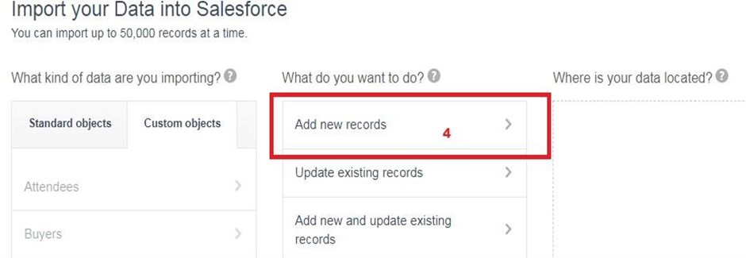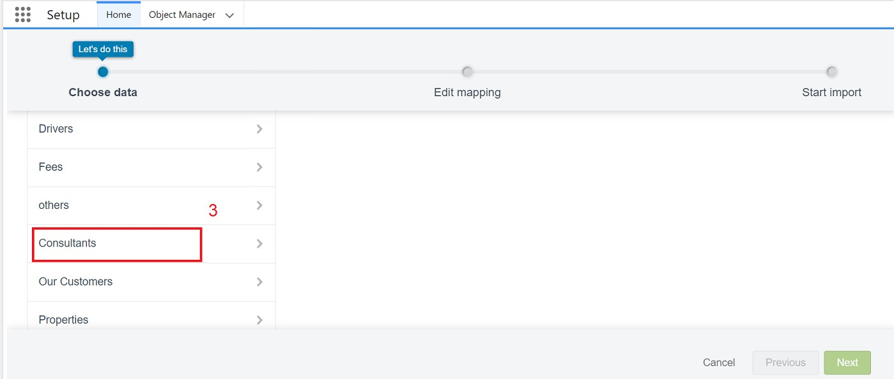

5.Select Add new records.

6.Click CSV and choose file Consultant_CSV which we made earlier. Click Next.

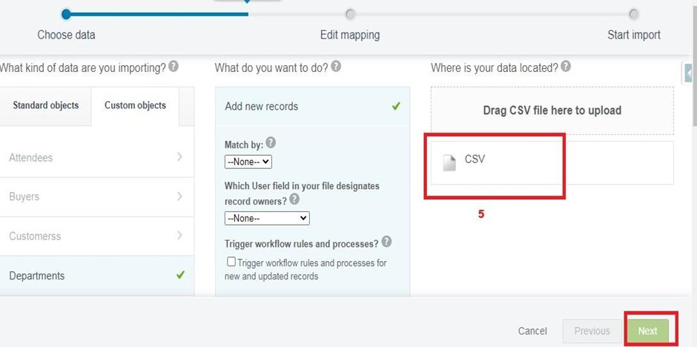

1. Since the field names in the CSV file (CSV Header) are the same as the field names in your object (Mapped Salesforce Object), the fields are automatically mapped. Click Next.

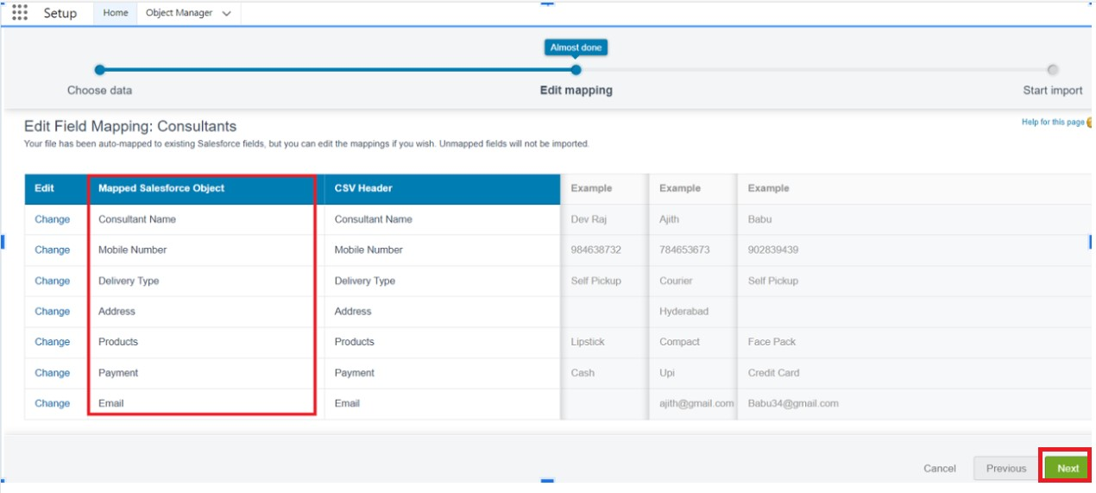

1. The next screen gives you a summary of your data import. Click Start Import.

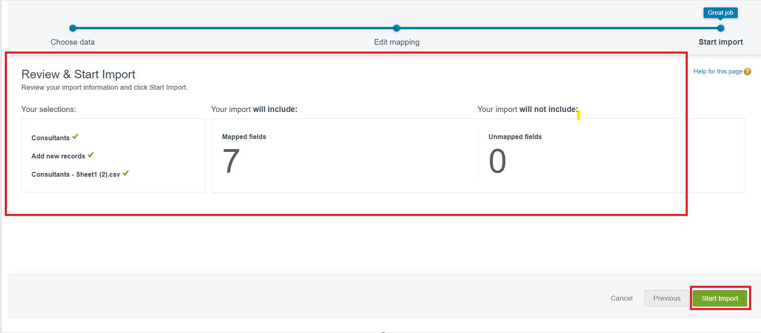

1. Click OK on the popup.

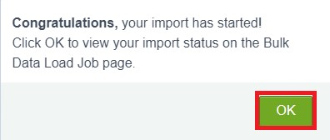

1. Scroll down the page and verify that your data has been imported under batches



1. Make sure you have 0 records under the records failed column.**Note** - Do Field mapping carefully.

**Task 10 :Accessing Reports :**

Creating Report **:**

Click App Launcher

2.Select Urban Color App

3.Click reports tab

4.Click New Report.

5.Click the report type as Consultants Click Start report.

6.Customize your report, in Columns select - ConsultantName,Delivery type,Products,Payment.

7.Click on the drop down option on the payment column and select Bucket this column.

8.Bucket Name as Payment type

9.Click on Add Bucket and name it as NetBanking

10.Click on Add Bucket and name it as Cash

11.Now Click on All Values and select Credit card,Debit card,Upi and Move to Net Banking.

12.Now Click on All Values again and select Cash and Move to Cash. 13.Click on Apply.

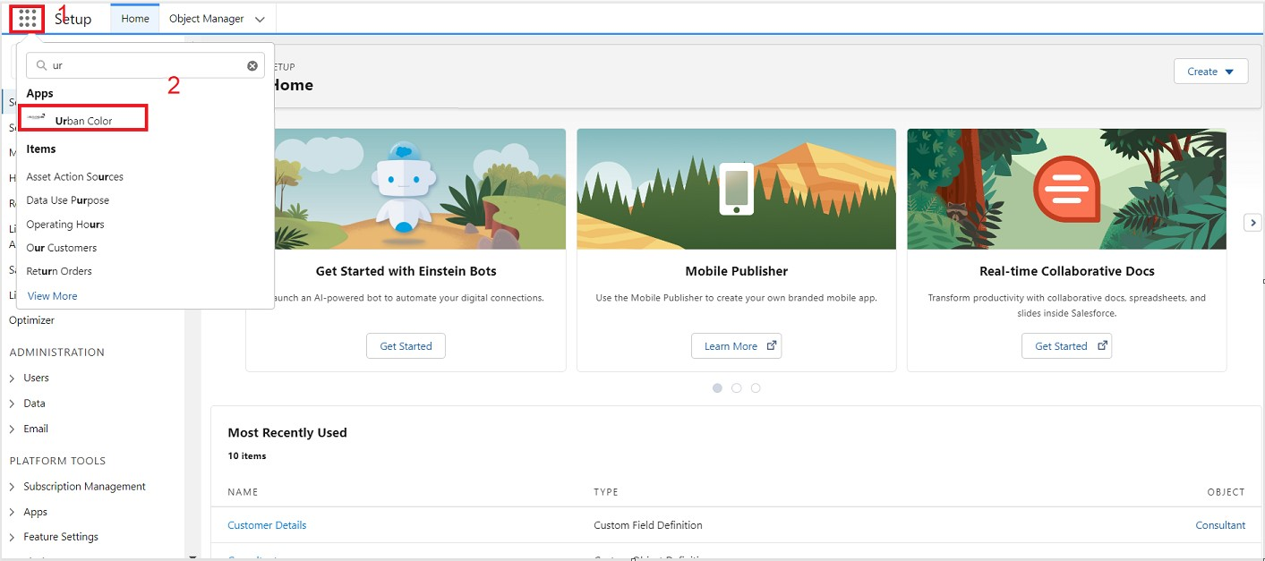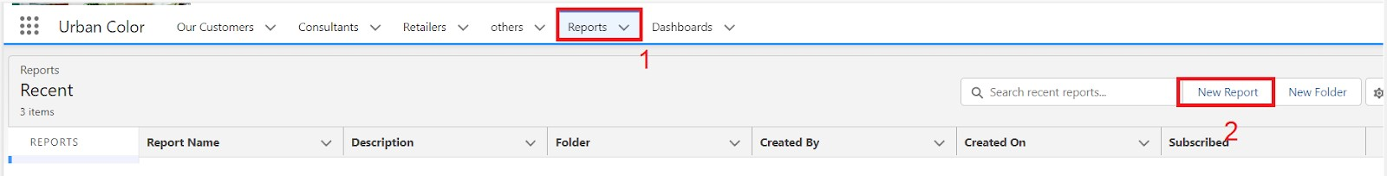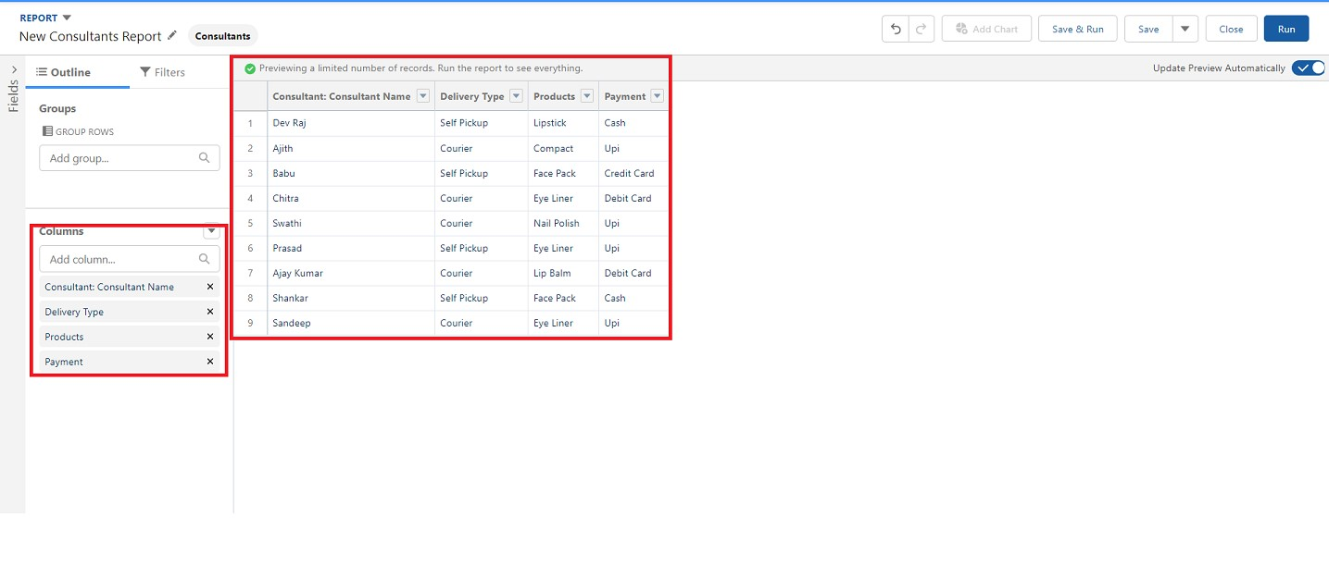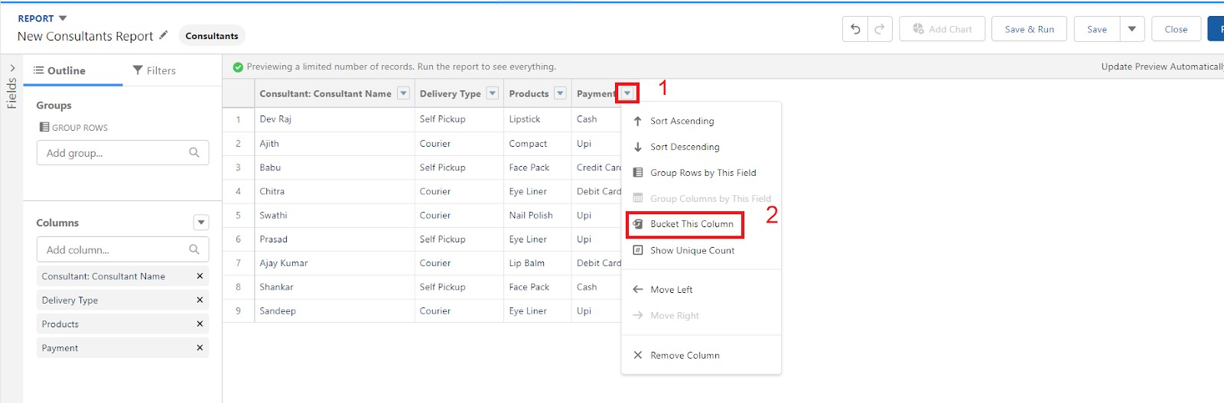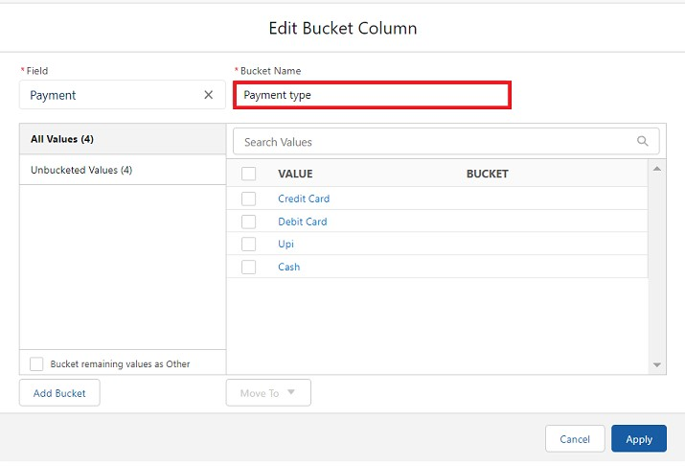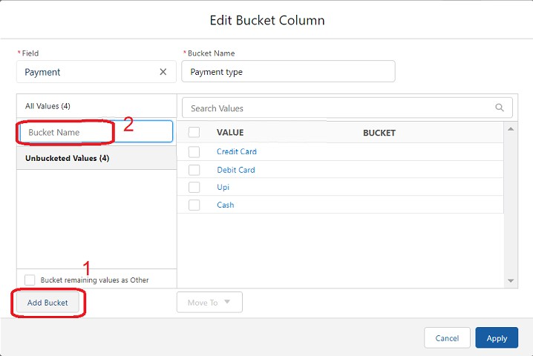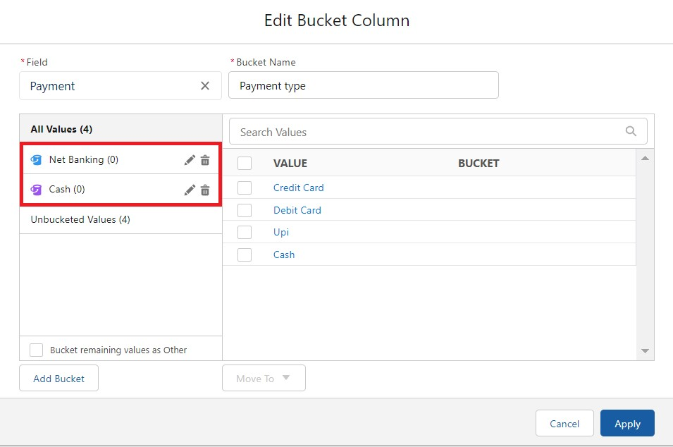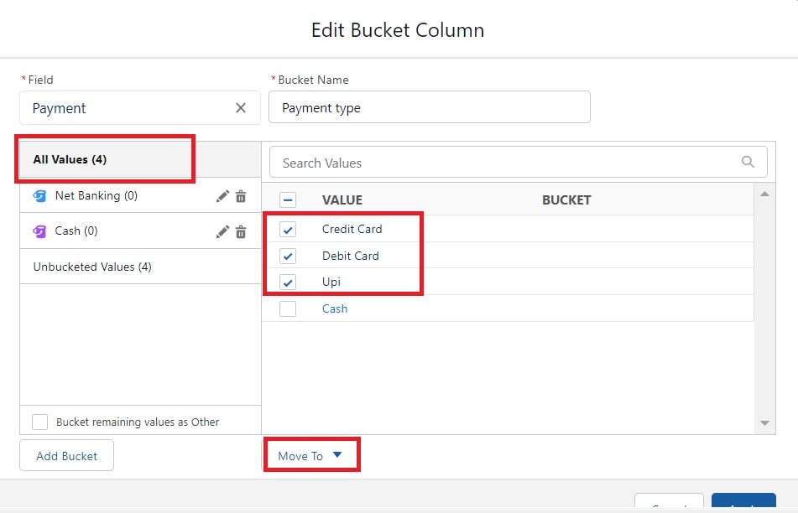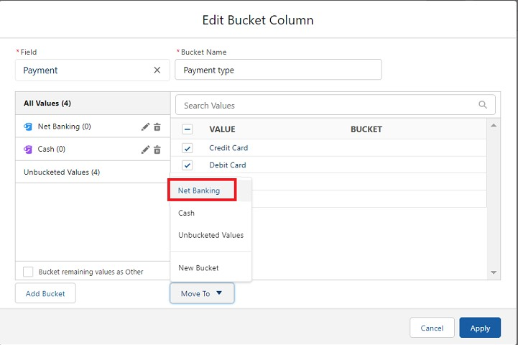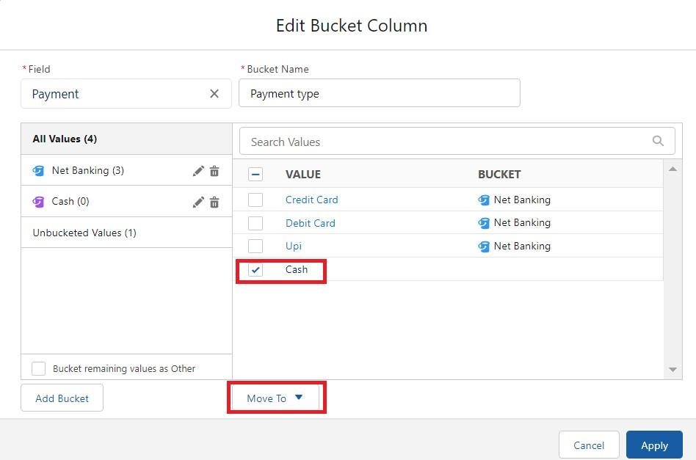

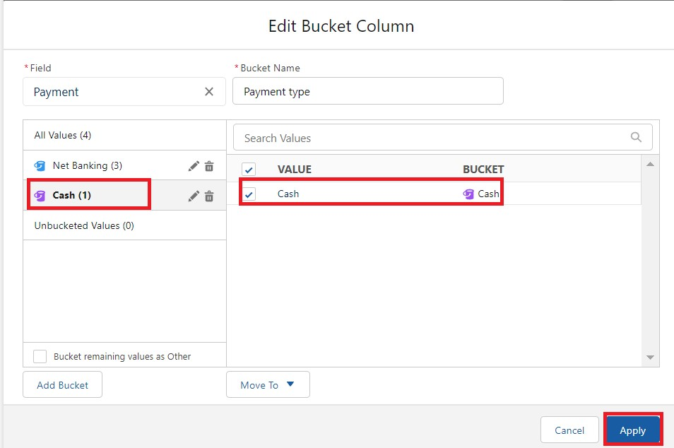

14.In Group Rows Add Payment Type Bucket Field.

15.Click refresh

16.Click Save and Run

17.Give report name – Consultant report

18.Click Save

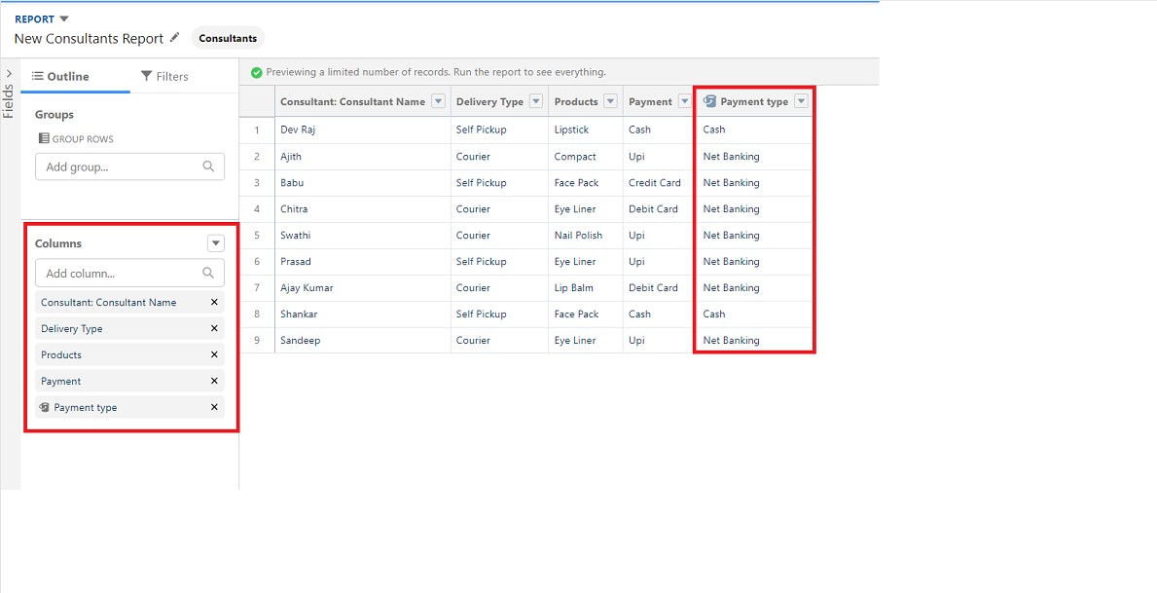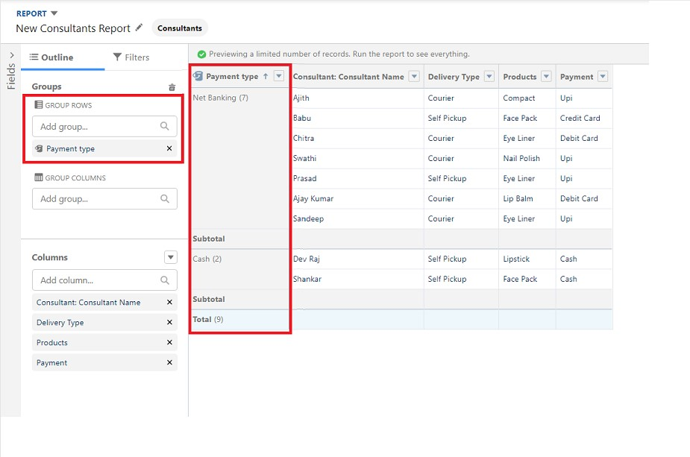

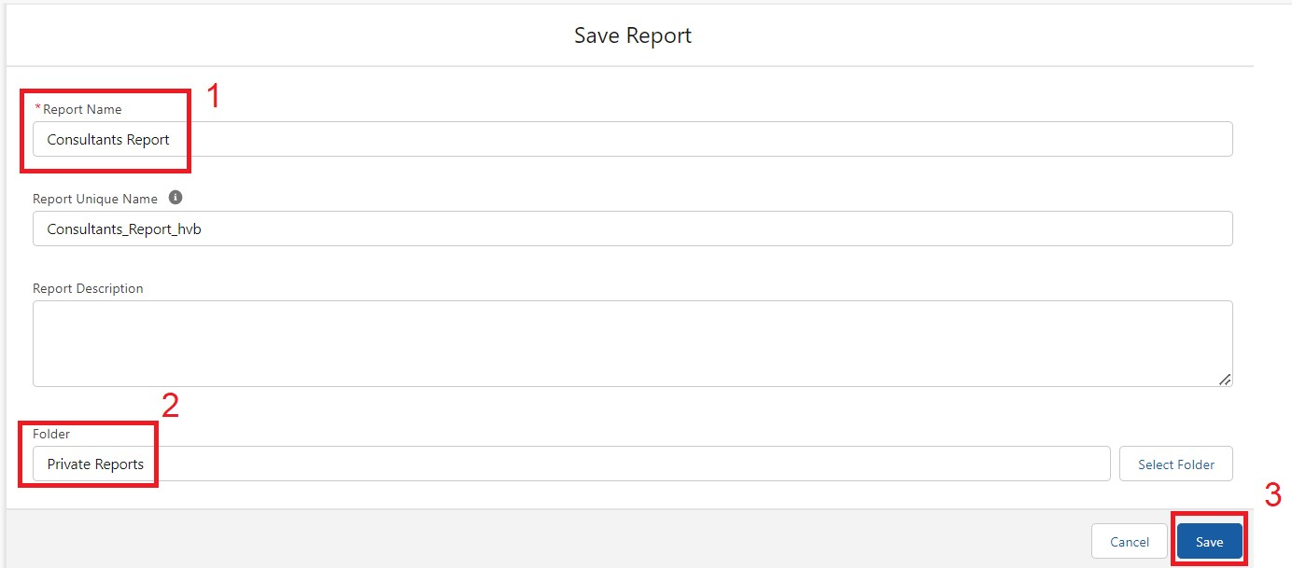

View Reports :

1. Click on App Launcher on the left side of the screen.
2. Search Urban Color App & click on it.
3. Click on Reports Tab.
4. Click on Urban Color Report and see records



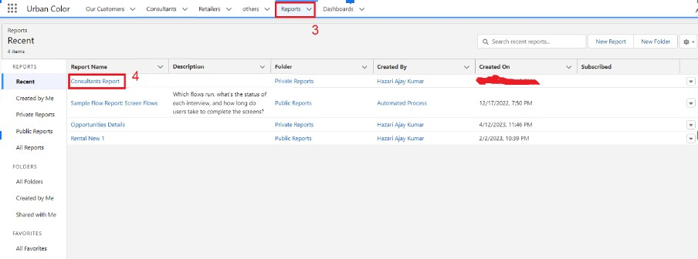

**Task 11 : Working with dashboards :**

**Create Dashboard**  **:**

1. Click on the Dashboards tab from the Urban Color application.
2. Click on the new dashboard.
3. Give name- Consultant Dashboard
4. Click create
5. Give your dashboard a name and click on +component
6. Select the Consultants Report which you created.
7. For the data visualization select any of the chart, table etc. as per your choice/requirement.
8. Click add.
9. Click save.

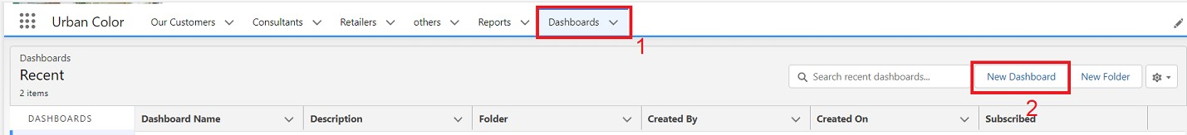

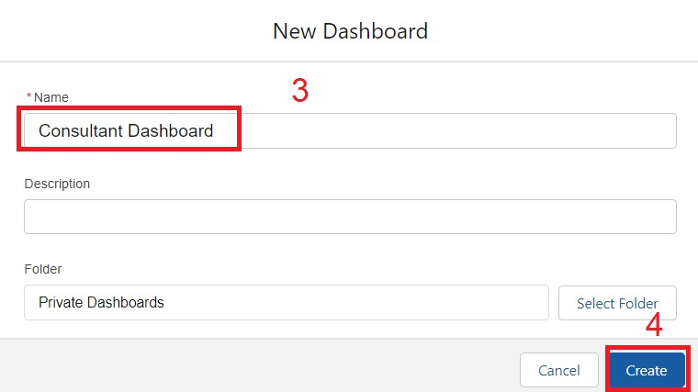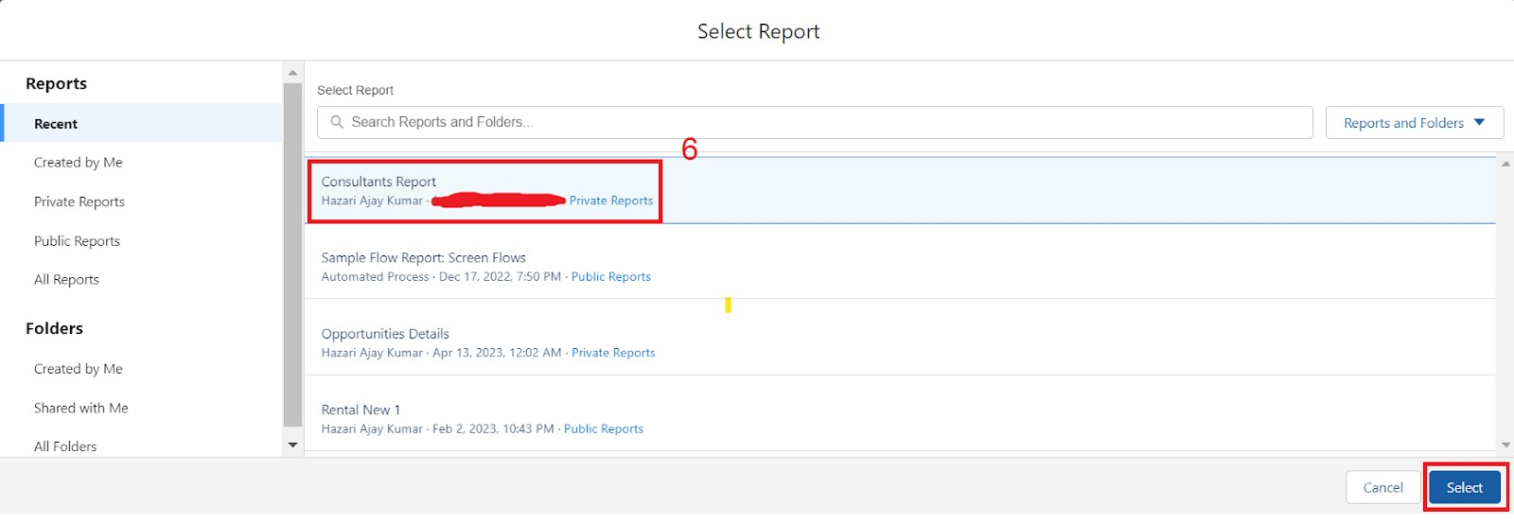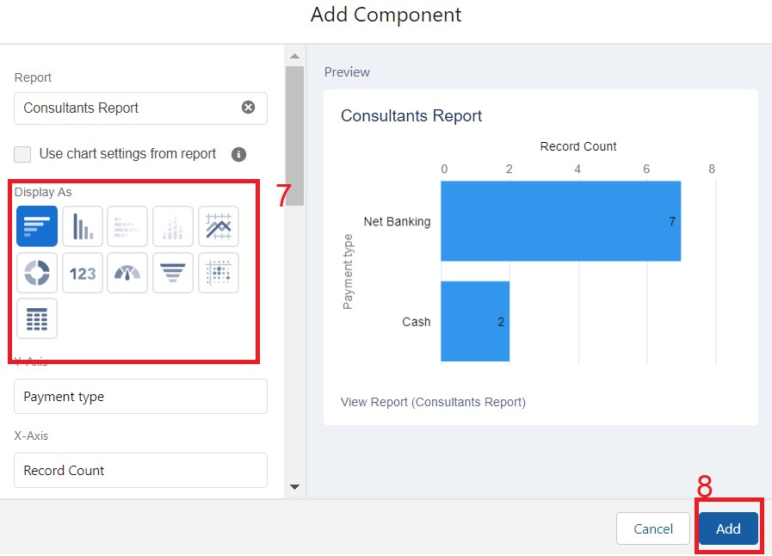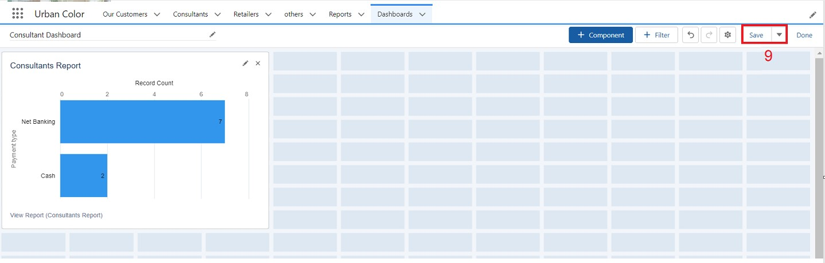

View DashBoard :

1. Click on App Launcher on the left side of the screen.
2. Search Candidate Internal Result Card & click on it.
3. Click on Dashboard Tab.
4. Click on Candidate Internal Result Card see graph view of records

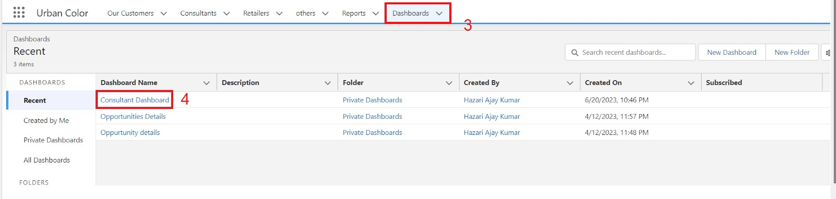

### THANK YOU